Chapter 2

Axioms of Probability

- Introduction
- In this chapter, the following basic concepts of probability will be introduced:
    - sample space;
    - event;
    - probability of an event;
    - basic assumptions (axioms) of probability theory.

  - Sample Space and Events
- Review of terms (mentioned previously in Chapter 1) ---
    - Experiment --- any human activity.
    - Outcome --- a result of an experiment.

- Some additional terms ---
    - Sample space of an experiment ---
The sample space of an experiment is the set S of all possible outcomes of the experiment.
    - Event ---
An event is a subset E of a sample space S, which is usually a set consisting of possible outcomes of a certain meaning.

- Example 2.1 ---
In an experiment of flipping two coins in order, we want to know if a head appears on the first coin. In this case, “flipping with a head appearing on the first coin” is an event. Therefore, we have
    - sample space S = {(H, H), (H, T), (T, H), (T, T)}, where H denotes the “head” of the coin and T the “tail”;
    - event E = {(H, H), (H, T)}.

- One more term and some notes ---
    - Occurrence of an event ---
If an outcome of an experiment is contained in an event E, then we say that E has occurred.
    - Some comments ---
Events are sets, so all set operations and related theorems can be applied to them. Also, outcomes are elements of sets of events.

  - Axioms of Probability
- Probability of an event ---
For each event E of the sample space S, it is assumed in probability theory that a number P(E) is defined, called the probability of E, which satisfies three basic assumptions, called axioms, described later.

- Notes ---
    - The above definition of probability is based on the modern axiomatic approach to probability theory.
    - How to measure or define probability will be explained later.
    - P(·) may be regarded as a set function (i.e., a function with sets constituting its domain).

- Some terms ---
    - Mutual exclusiveness ---
Two sets are said to be mutually exclusive if their intersection is an empty set φ.
    - Axiom ---
An axiom is a proposition (提議或主張) that is considered to be self-evident and serves as a starting point for deducing and inferring other facts. No proof of it is provided.

- Three axioms of probability ---
With S being a sample space and E an event, we have the following axioms for use in probability theory:
    - Axiom 1:
0 ≤ P(E) ≤ 1.

    - Axiom 2:
P(S) = 1.

    - Axiom 3:
For any sequence of mutually exclusive events E₁, E₂, ..., the following equality holds:
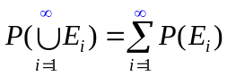.

- A note ---
Axiom 3 says that the probability of the union of all mutually exclusive events is the sum of their respective probabilities.

- Two facts deduced from the axioms ---
    - Fact 2.1:
P(φ) = 0.
Proof:
Easy. As an exercise.

    - Fact 2.2:
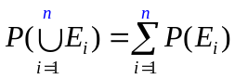.

Proof:
To prove Fact 2.1, let E₁ = S, and E_{i} = φ for all i > 1. Then, 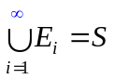, and from Axiom 3, we have
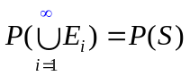=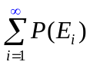=P(S) + 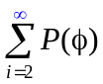,
which means that = 0, or equivalently, that P(φ) = 0 according to Axiom 1.
To prove Fact 2.2 for a finite sequence of mutually exclusive events E₁, E₂, …, E_{n}, let E_{i} = φ for all i > n. Then, by the above fact (Fact 2.1) and the fact 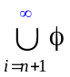 = φ, the left-hand side of Axiom 3 may be reduced to
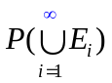=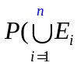+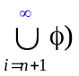= + φ) = 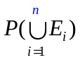. (A)
Also, using Fact 2.1 again, the right-hand side of Axiom 3 may be reduced to
=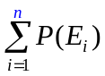+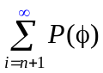 = +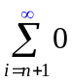=. (B)
Finally, by Axiom 3 and the above results (A) and (B), we get the result of Fact 2.2. Done.

- A note on Axiom 3 and Fact 2.2 ---
When the sample space is infinite, then Axiom 3 is used; otherwise, Fact 2.2 is applied. An example of infinite sample spaces is the set of all integers.

- How to define or measure a probability value ---
    - For a “basic” probability, define it by intuition or by frequency counting.
    - For a “composite” probability, compute it by axioms, or by derived facts or propositions from the axioms.

- Example 2.2 ---
In tossing a “fair” coin, we have:
    - sample space --- S = {H, T} where “H” and “T” mean the head and tail of the die, respectively;
    - events --- E₁ = {H}, E₂ = {T} (i.e., events of appearing to be a head and a tail, respectively); and
    - “basic” probabilities for the two events E₁ and E₂ by intuition based on the fairness assumption respectively are:
P(E₁) = 1/2, P(E₂) = 1/2.

- Example 2.3 ---
In tossing a “fair” die, we have:
    - sample space --- S = {1, 2, 3, 4, 5, 6};
    - events --- {1}, {2}, ..., {6} (i.e., events with each appearing to be any of the six die sides); and
    - “basic” probability for each of the six events by intuition based on the fairness assumption is:
P({i}) = 1/6
for i = 1, 2, …, 6.
(Note: events are sets written in the form of {·}.)

- Example 2.4 ---
What is the probability of rolling an even number with a die?
Solution:
    - The event of rolling an even number is E_{even} = {2, 4, 6}.
    - From the result of the last example and Fact 2.2, and by mutual exclusiveness of the events {2}, {4}, {6}, we get the “composite” probability of E_{even} as
P(E_{even}) = P({2, 4, 6}) = P({2}U{4}U{6})
= P({2}) + P({4}) + P({6}) (by Fact 2.2)
= 1/6 + 1/6 + 1/6
= 1/2.

- How to define basic probability values by frequency counting ---
    - A classical way of defining a certain probability value is to measure it by frequency counting.
    - An example ---
To define the basic probability P(E) of the event E of tossing a coin with a head H as the outcome, the classical way is to conduct the following process:
      - repeat the tossing for n times with n large enough;
      - find the number of times n₁ with H appearing as the outcome;
      - define the desired probability P(E) as
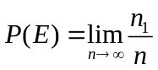.
    - A note ---
The above way of defining probability values by frequency counting is intuitively sound but theoretically complicated because how can we know if the limit exits and converges?
However, it may be proved to be correct by the strong law of large number (a theorem to be proved in Chapter 7).

  - Some Simple Propositions
- Review of the set theory (I): basic operations ---
Given sets E, F, and G, and assume U as the “universal set,” the following are definitions of some common set operations:
    - union: EUF = {x | x ∈ E or x ∈ F};
    - intersection: E∩F = {x | x ∈ E and x ∈ F};
    - subtraction: E−F = {x | x ∈ E and x ∉ F};
    - complementation: E^{C} = {x | x ∈ U and x ∉ E}.
(Note: the universal set U in the set theory is equivalent to the sample space S in the probability theory)

- Review of the set theory (II): well known laws ---
The following are some well-known laws about set operations:
    - commutative laws: EUF = FUE;
E∩F = F∩E;
    - associative laws: (EUF)UG = EU(FUG) ≡ EUFUG;
(E∩F)∩G = E∩(F∩G) ≡ E∩F∩G;
(recall: “≡” means “equals by definition”);
    - distributive laws: (EUF)∩G = (E∩G)U(F∩G);
(E∩F)UG = (EUG)∩(FUG);
    - DeMorgan’s laws: (EUF)^{C} = E^{C}∩F^{C};
(E∩F)^{C} = E^{C}UF^{C}.

- Review of the set theory (III):Venn’s diagrams ---
    - Many set operations and laws may be verified by the use of Venn’s diagrams as shown in the following.
    - In these Venn’s diagrams, the left, right, and bottom circles are sets E, F, and G, respectively; and the set operation result is the darkest portion.

(1) E∩F = 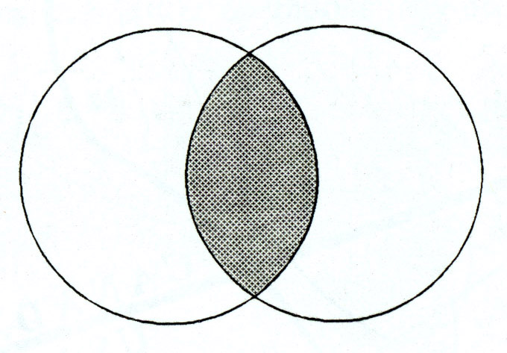. (2) EUF = 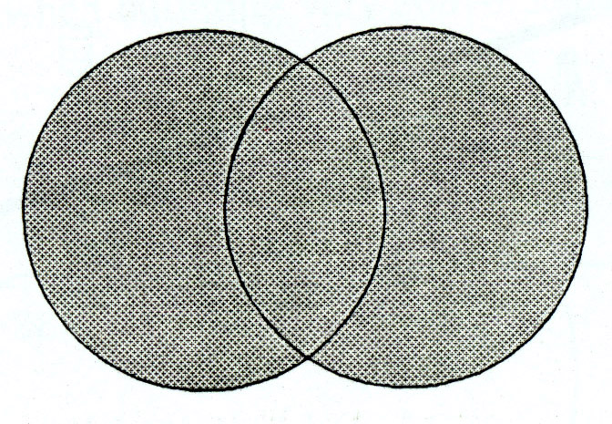.

(3) E − F = 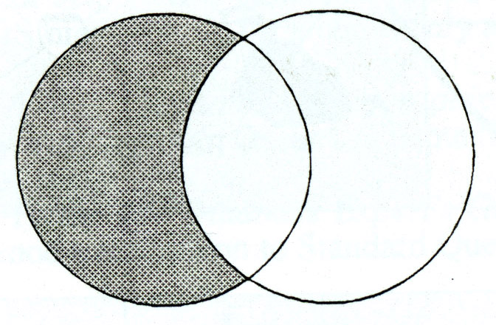. (4) E^{C} = .
(rectangular area = universal set U)

(5) E∩(FUG) = 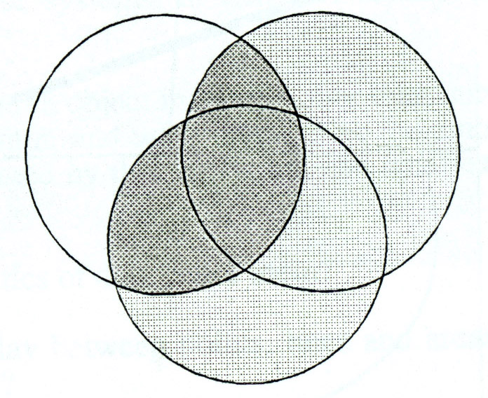. (6) (E∩F)UG = 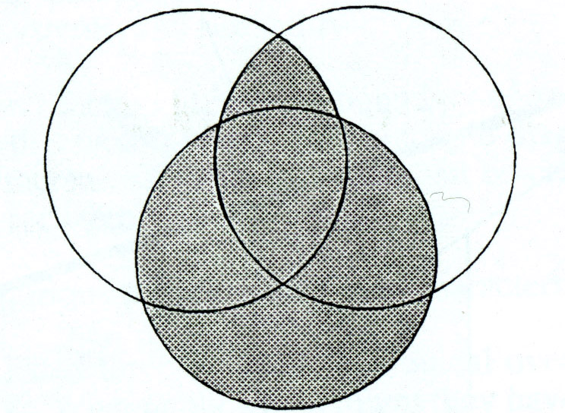.
(light gray part = FUG)

- A simplification of the notation for intersection ---
From now on, the intersection notation ∩ will be omitted unless ambiguity arises or unless emphasis is necessary. So, E∩F will be written as EF, for example.

- Explanations of some terms about derived facts:
    - A term may either be undefined (with a common-sense meaning) or defined (with a particularly assigned meaning).
    - The word “fact” is used in this course as a defined term expressing a result derived from others (note: in this sentence, for example, the word “result” is used as an undefined term).
    - “Rules,” “laws,” “propositions,” “lemmas,” “theorems,” “corollaries,” are all formal facts derived from terms, axioms, or/and other facts.
    - Lemmas and propositions usually are simpler or less “significant” than theorems, and are derived in advance for use in deriving theorems.
    - Corollaries usually are simply-derivable facts from theorems.

- Some notations and a note ---
    - In the following discussions, E, F, and E_{i} for all i = 1, 2, … denote events.
    - Recall that events are sets.

- Three propositions ---
The following three propositions are intuitively true; the proofs of them are left as exercises.
    - Proposition 2.1:
P(E^{C}) = 1 − P(E).
    - Proposition 2.2:
If E ⊂ F, then P(E) ≤ P(F).
    - Proposition 2.3:
P(EUF) = P(E) + P(F) − P(E∩F).

- Example 2.5 ---
In tossings of two fair coins one by one, what is the probability that either the first outcome or the second one is a head?
Solution 1:
The desired probability may be computed as an application of Proposition 2.3 in the following way:
    - sample space S = {(H, H), (H, T), (T, H), (T, T)} for the two tossings;
    - all events with each constituting an outcome in S are mutually exclusive;
    - each point in S has a probability of 1/4;
    - event E = {1st outcome = H} = {(H, H), (H, T)};
    - event F = {2nd outcome = H} = {(H, H), (T, H)};
    - desired event G = EUF;
    - desired probability P(G) = P(EUF) = P(E) + P(F) − P(EF); (C)
    - EF = {(H, H)}
    - P(E) = P(F) = ¼ + ¼ = ½; (by Fact 2.2)
    - P(EF) = ¼;
    - so (C) above becomes P(G) = ½ + ½ − ¼ = ¾ as the final result, proving the validity of Proposition 2.3 above.

Solution 2:
The above result may also be computed directly as follows:
    - G = EUF = {(H, H), (H, T), (T, H)};
    - P(G) = P(EUF) = ¼ + ¼ + ¼ = ¾. Done.

  - Sample Spaces Having Equally Likely Outcomes
- A generalization of Example 2.4 ---
Assume the following facts:
    - sample space S = {1, 2, ..., N} (with N integer values);
    - P({1}) = P({2}) = ... = P({N}) (“all outcomes are equally likely”).
Then, we have the following reasoning:
    - Axiom 2 and Fact 2.2 imply P({i}) = 1/N for i = 1, 2, ..., N (check why by yourself);
    - Fact 2.2 again implies that
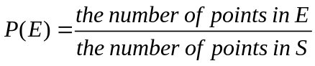
(check why by yourself again).
    - Accordingly, we have the following fact.

- Fact 2.3:
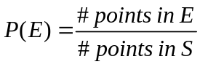
where for simplicity, we use “#” to mean “the number of.”

- Example 2.6 ---
If two balls are randomly drawn without replacement (i.e., not put back) from a bowl containing 6 white and 5 black balls, what is the probability that one of the drawn balls is white and the other black?
Solution 1:
    - Concept of solution --- regarding the order of selecting balls as significant;
    - total number of balls = 11 with 6 white and 5 black balls with them being denoted as W and B, respectively;
    - sample space S --- including 11×10 = 110 outcomes by the basic product principle of counting (note: the drawings are conducted without replacement);
    - “randomly drawn” means 110 outcomes are “equally likely to occur;”
    - event E --- “one white and one black drawn”;
    - E includes two types of mutually exclusive events:
(1) E₁ --- first white and second black;
(2) E₂ --- first black and second white;
    - so E = E₁UE₂;
    - #outcomes in E₁ = 6×5 = 30 (here, outcomes = (W₁, B₁), (W₁, B₂), …);
    - #outcomes in E₂ = 5×6 = 30 (here, outcomes = (B₁, W₁), (B₁, W₂), …);
    - the desired probability so is
P(E) = P(E₁UE₂) = [P(E₁) + P(E₂)] (by Fact 2.2)
= 30/110 + 30/110 = 6/11. (by Fact 2.3)

Solution 2:
    - Concept of solution --- regarding the outcomes of the experiment as an unordered set of drawn balls;
    - sample space S --- including C(11, 2) = 55 different outcomes;
    - event E --- “one white and one black drawn”
    - E includes C(6, 1)×C(5, 1) = 6×5 = 30 possible outcomes (see Example 1.4 of Chapter 1 for the involved concept);
    - the desired probability so is
P(E) = 30/55 = 6/11. (by Fact 2.3)

  - ***Probability Is a Continuous Function
(*** means “may be skipped”)

- Some terms and notations ---
    - An increasing sequence of events ---
a sequence of events {E_{n} | n ≥ 1} where E₁⊂E₂⊂...⊂ E_{n}⊂E_{n+1}⊂... (i.e., E₁ is the “smallest” set).

    - A decreasing sequence of events ---
a sequence of events {E_{n} | n ≥ 1} with E₁⊃E₂⊃...⊃E_{n}⊃E_{n+1}⊃... (i.e., E₁ is the largest set).

    - For an increasing sequence of events {E_{n} | n ≥ 1}, define 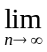E_{n} = 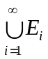, which intuitively is the “largest set at the infinitive end of the sequence.”

    - For an decreasing sequence of events {E_{n} | n ≥ 1}, define E_{n} = 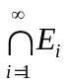, which intuitively is the “smallest set at the infinitive end of the sequence.”

- Proposition 2.4 ---
If {E_{n} | n ≥ 1} is either an increasing or decreasing sequence of events, then
P(E_{n}) = P(E_{n}).
Proof: see the reference book.

- A comment --- the above proposition means the continuity of the probability function.

  - Probability as a Measure of Belief
- Probability: relative frequency versus belief ---
    - Probability is intuitively a measure of the relative frequency of an event with respect to the total sample space of an experiment, as described previously.
    - Probability may also be regarded as a measure of one’s belief from the personal or subjective view of probability.

- Examples of probability as a measure of belief ---
    - your thought of feeling happy tomorrow;
    - the chance of meeting a friend in a bus this afternoon;
    - the chance of winning a horse race.

- A comment --- probability of this kind is similar to the fuzzy membership value in the fuzzy set theory.

